# Simulation Plan:

You can click to any of the ones that are completed/ bolded.  
This plan is not fixed, and can be altered according to schedule or other external events.

**1. Simple Simulation: 1 EV, 1 CS (1 port), Grid, Solar Power. (COMPLETED)**

2. Multiple EVs and Charging Stations.

3. Implement any Optimization Algorithm to the Simulation.

4. Look into existing papers and study how they forecast the load and solar power. Implement that to the simulation.

5. Implement any DRL Algorithm to the Simulation. (This simulator support RL gym environment, so I want to play around with it in this part).

6. Compare the Performances of these 3 Algorithms (Uncontrolled algorithm, Optimization algorithm, DRL algorithm).

7. Battery degradation. In this part, the goal is to experiment with various battery models that have existed, as well as look into the battery degradation model that has been included in this simulator.

8. Look into carbon aware emission metrics. The goal is to figure out how to keep track the amount of carbon these EVs can save compared to traditional cars as well as compared to uncontrolled charging.

9. Try to replicate an algorithm from a state-of-the-art paper (one of the papers that I have discussed with Dr. Dande).

# **1. Simple Simulation: 1 EV, 1 CS (1 port), Grid, Solar Power. (COMPLETED)**:

In this simulation, there exist **1 EV, 1 charging station with 1 port, grid, load and solar power.**

The grid here does not only generate electricity through solar power, but also generate power through traditional means, which I call traditional power.  
The goal is to achieve power balance: supply == demand  
The diagram below detail the outline of the simulation:  
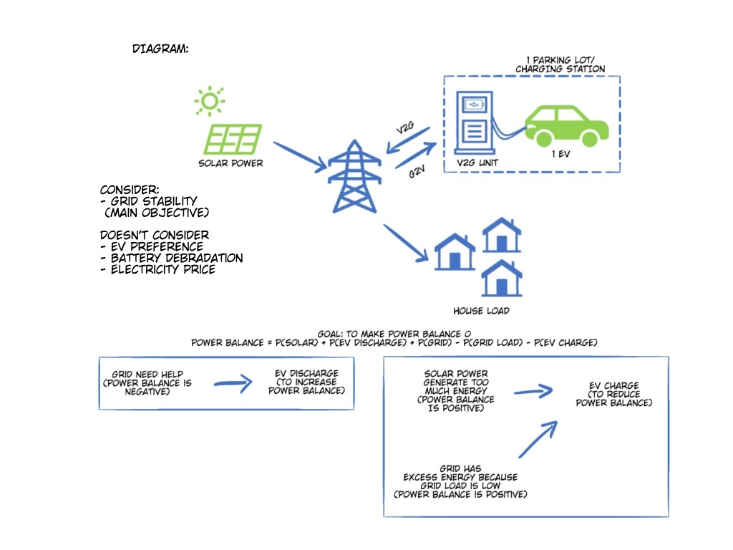

**My thoughts after finishing the simulation:**

I utilize the **EV2Gym simulator.**

The result is: successful

In this simulation, I mention the use of traditional power, power generated through other means aside from solar power. If there are excess power from these traditional power + solar power, EV will charge. But in actuality, **what we want is to minimize the use of this traditional power, and maximizing the use of the solar power.** So, in the next simulation, for the power balance equation, I won’t be including traditional power generation, as this electricity generation is produced real time to meet the demand. **What we want here is carbon neutrality**, meaning: solar power – load – EV charging + EV discharging = 0.

**Simulation setting:**

- The load, solar power and traditional power generated (power generated not using RE) by the grid **are all provided by the simulator** through the probability distribution that they have created through numerous datasets they have gathered. This also apply to the departure and arrival time of the EV.

- I want to note that it is possible to control these through a config (yaml) file. However, I find them to be hard to control, so there is a huge change that I will modify this or find my own dataset for the grid as well as the load. The config file I am referring to (just a part of it):

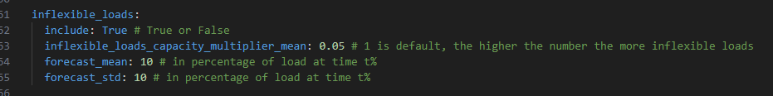

What do I mean by hard to control? I use a multiplier of 0.05 above, and it leads to some runs having a “scale negative” bug. My guess is that the minimum value for this setting is supposed to be 1. I put 0.05 here so that I can try to showcase my EV charging. Because if I put it as 1, then the load is too high, forcing the EV to not charge or discharge.

- Furthermore, **the traditional power generated by the grid uses the simulator’s generate_power_setpoint function in utils.py**. In actuality, the generate_power_setpoint is not used to generate traditional power**, I just use it as a placeholder for now.**

- The **forecasting** of load and solar power for the current timestep is not done through fancy algorithms. It is just using the actual data from the previous timestep.

- In this simulation, **EV’s desired SOC is considered. If the EV’s SOC < desired SOC at the current time step, it will not discharge.**

**-** I do want to point out that there is a bug in their “desired_capacity” when they spawn the ev. For this simulation, I have fixed it

**Simulation Result:**

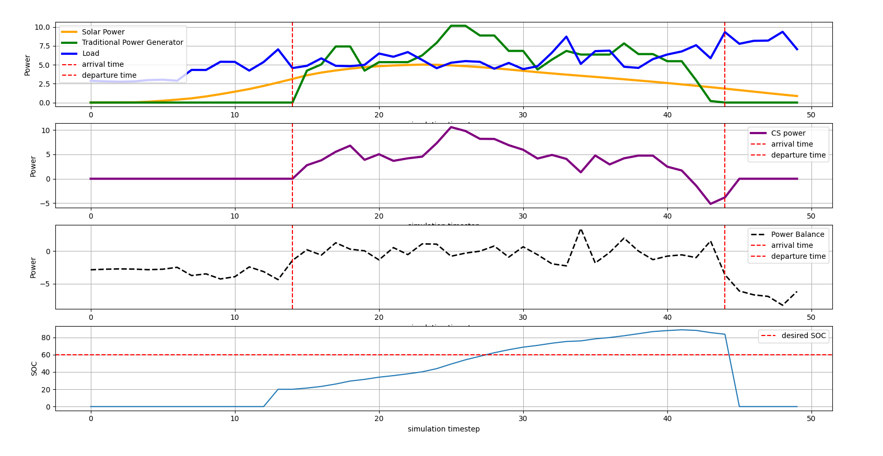  
- The red line is the arrival and departure time of the EV.

- The second figure (purple line) shows the charging and discharging of EV. If it is below 0, it is discharging.  
- When the EV arrive, the power balance is much closer to 0 compared to the timestep when EV was not there. This shows that EV helps in grid stability.

- V2G is successful as seen in timestep 43. The CS power is negative as EV is discharging to help the grid, because the load is higher than the traditional power and solar power combined.